Name – Yash Atul Patil [Email= yapatil2365@gmail.com](mailto:Email=%20yapatil2365@gmail.com) Batch date-9-08-2021

Batch name = advance sql

Database= employees_mod

Dataset = Employees.db

Q1> find out the department name and gender with their salary

use employees_mod;

SELECT

gender,salary,dept_name

FROM

t_employees

JOIN

t_dept_emp ON t_employees.emp_no = t_dept_emp.emp_no

LEFT OUTER JOIN

t_salaries ON t_salaries.emp_no = t_employees.emp_no

left outer join t_departments on t_departments.dept_no=t_dept_emp.dept_no;

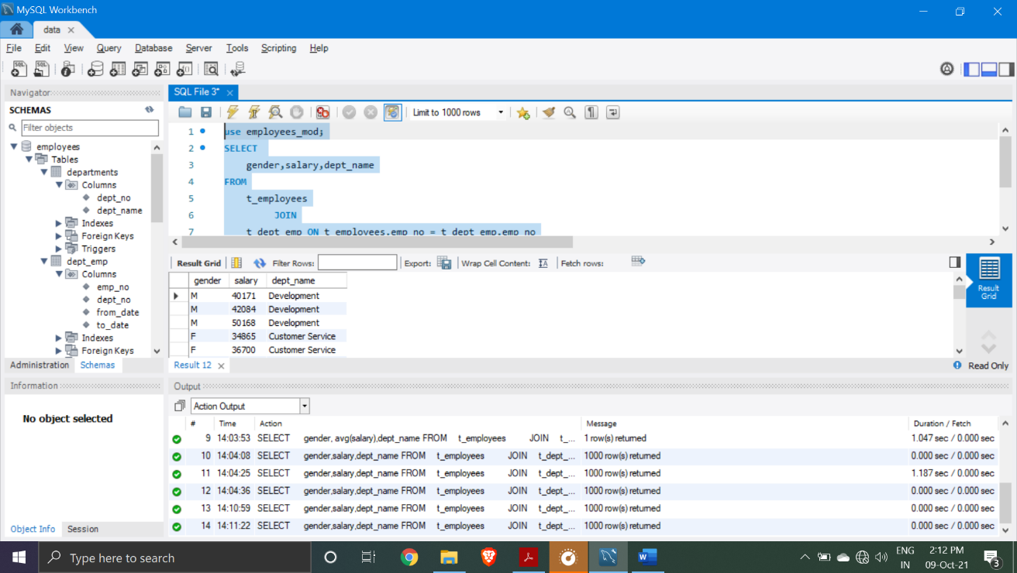

Q2> select emp no and first name starting with Y letter

select emp_no , first_name from t_employees where first_name like 'Y%';

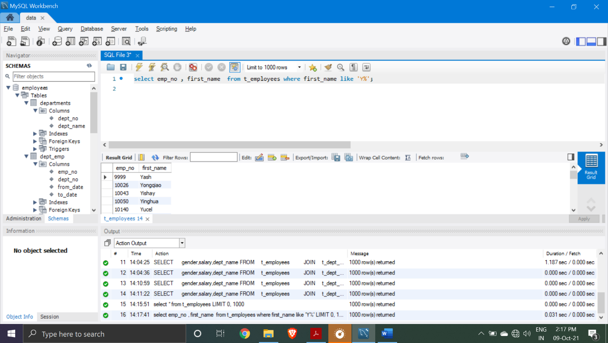

Q3> select maximum and minimum salary from the database

SELECT

MAX(salary) as minimum_salary, MIN(salary) as maximum_name

FROM

t_salaries;

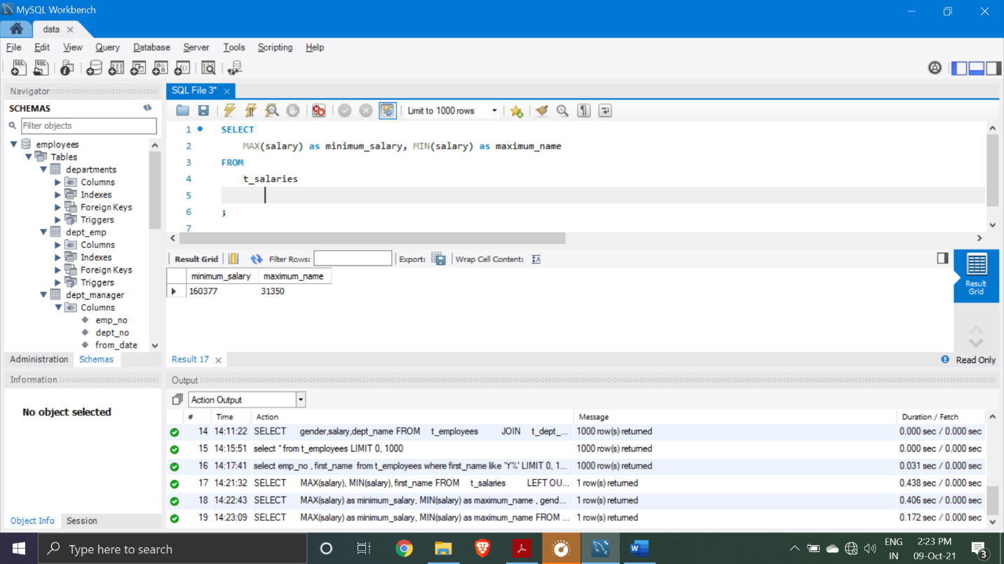

Q4> Retrieve a list of all employees that have been hired less than year 2000.

SELECT

YEAR(hire_date) AS year_of_hiring, first_name, last_name

FROM

t_employees

WHERE

YEAR(hire_date) <= '2000';

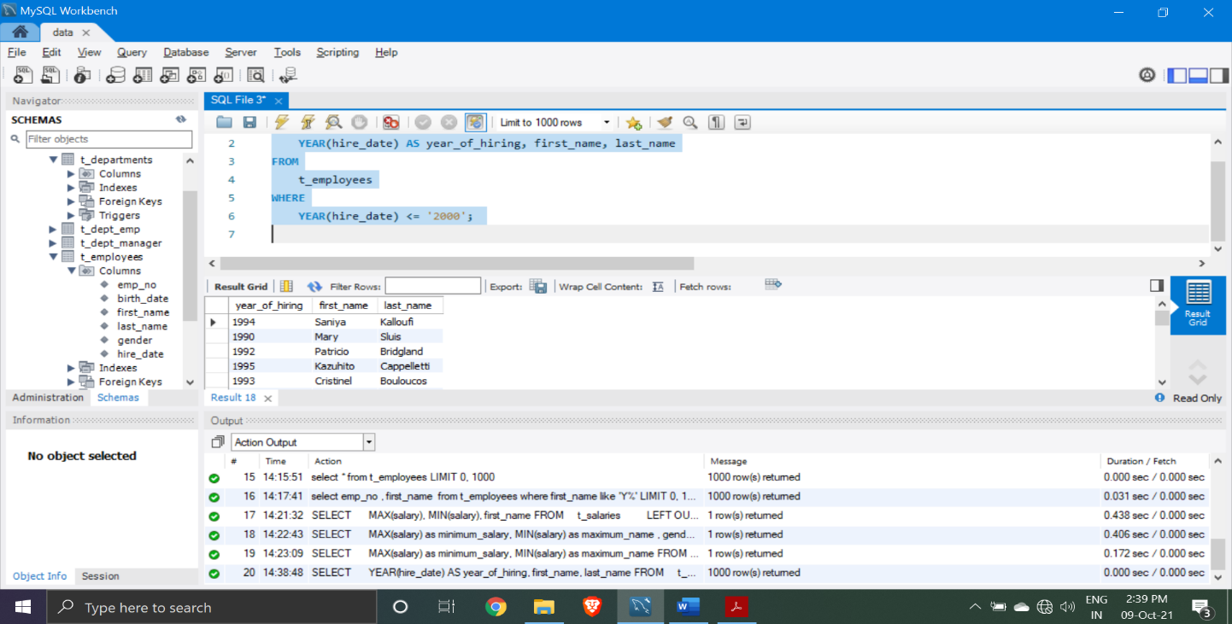

Q5>create the table name vash contain the avg_salary , gender , department_name

drop table yash ;

CREATE TABLE yash (

avg_salary int ,

gender varchar(567) ,

department_name varchar(567)

); 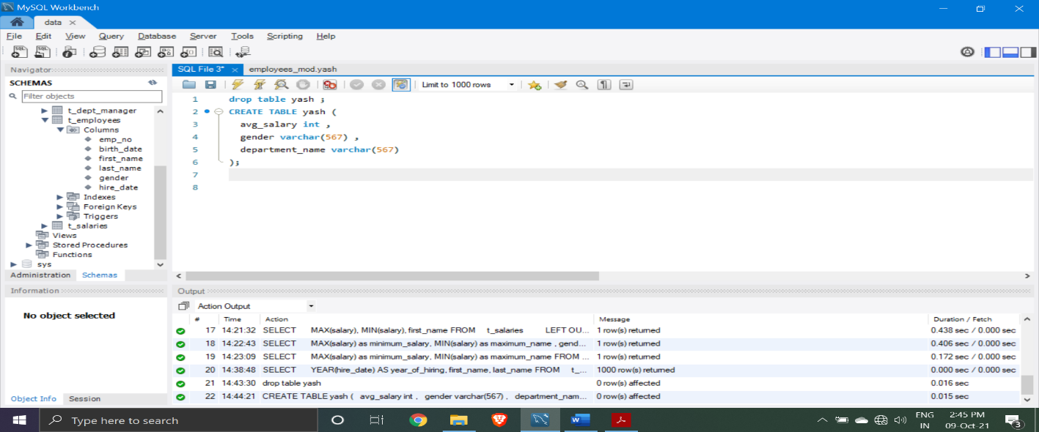

Q6> join both t_salaries and t_employees using cross join

SELECT

t_salaries.*, t_employees.*

FROM

t_salaries

CROSS JOIN

t_employees ON t_salaries.emp_no = t_employees.emp_no;

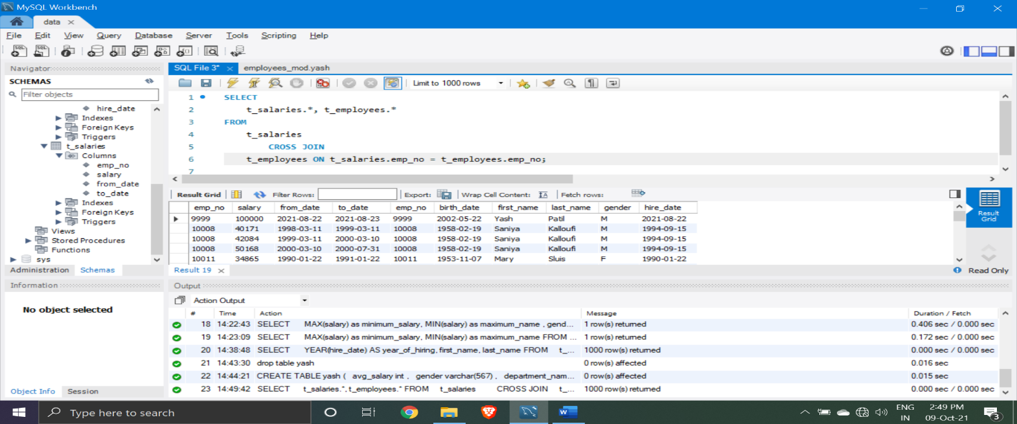

Q7> count the departments number

select count(dept_no) from t_departments;

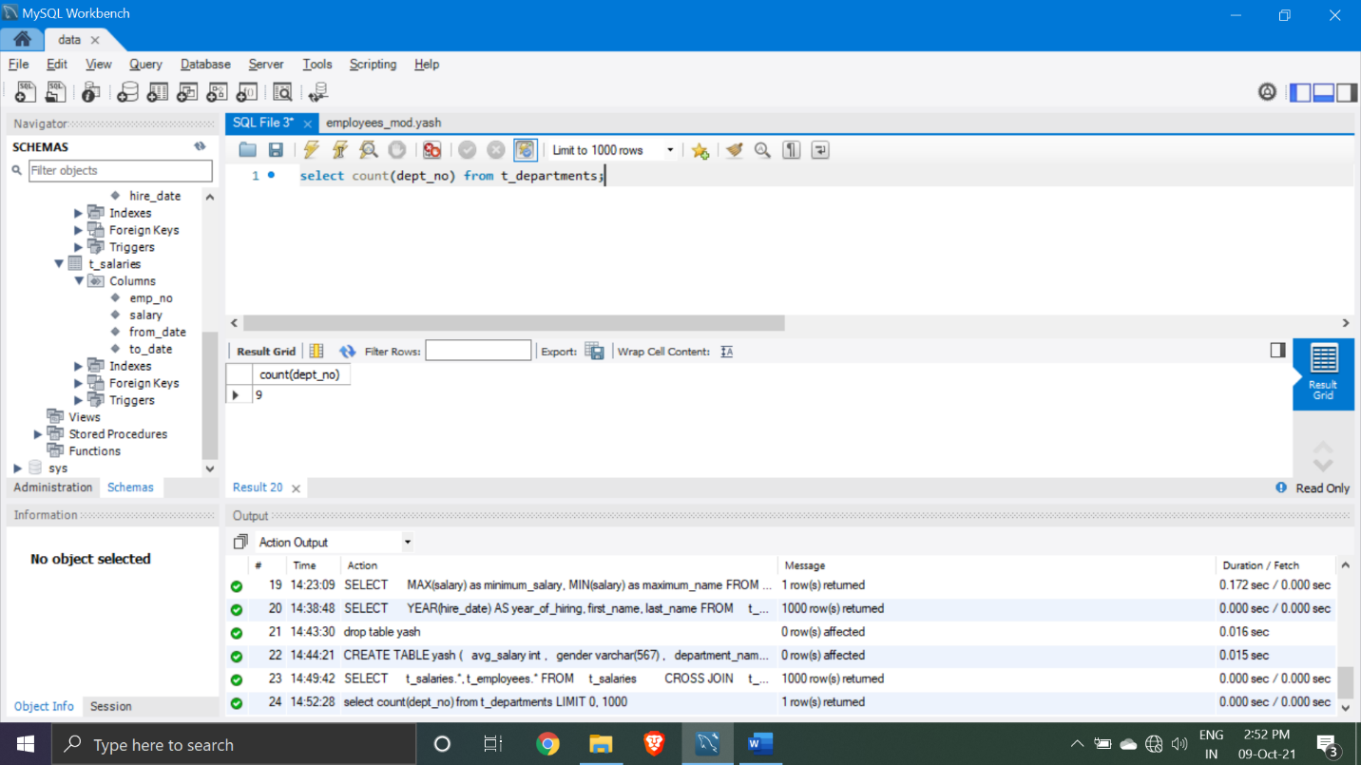

Q8> find out the employees who has hired between the year 1990 to 1998

SELECT

first_name, last_name,hire_date

FROM

t_employees

WHERE

YEAR(hire_date) BETWEEN '1990' AND '1998' order by hire_date;

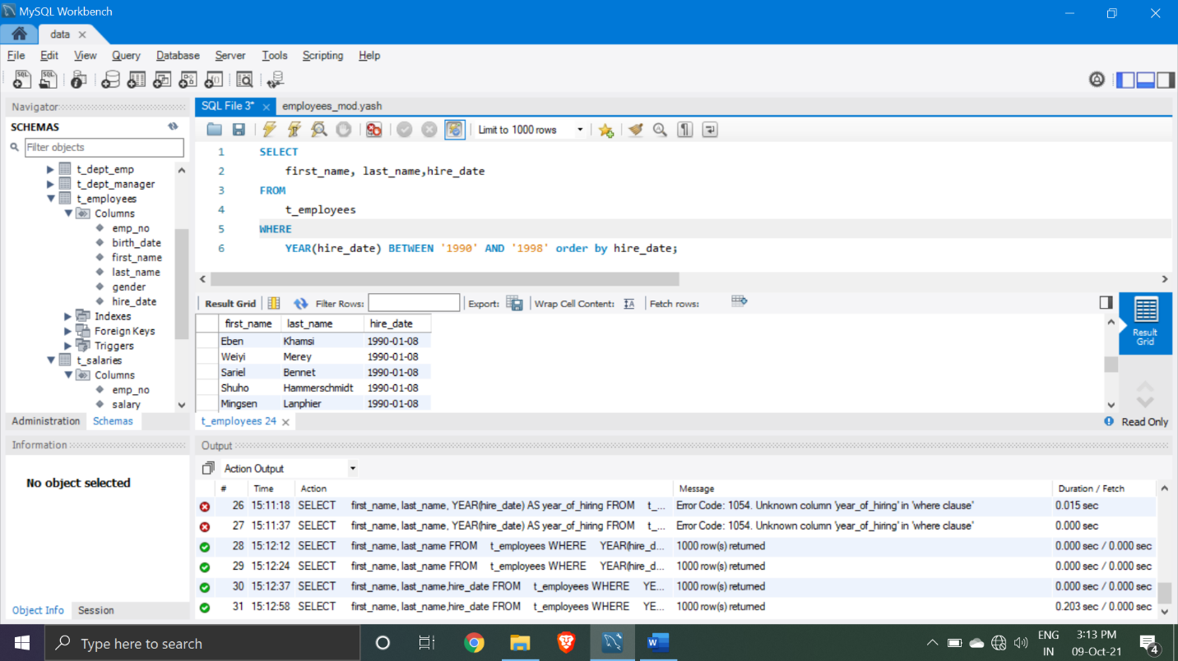

Q9> insert new data in t_salaries column

insert into t_salaries values(9090,4000000,'2021-09-22','2021-08-20');

select* from t_salaries;

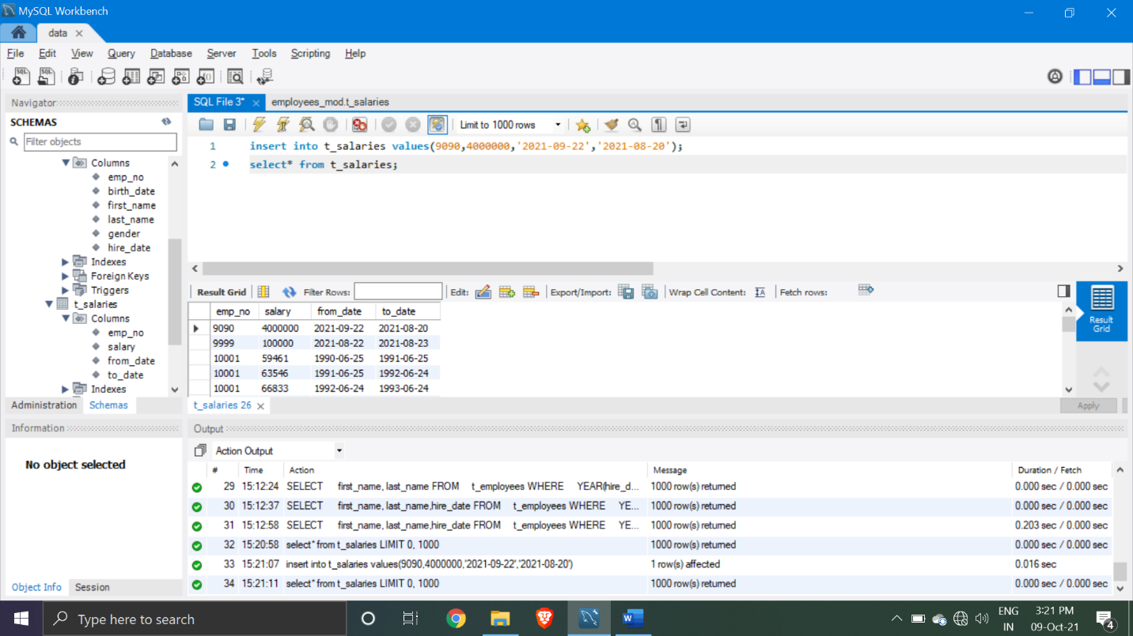

Q10> update the salary details having employees number is 10001

update t_salaries set salary = 1

where emp_no=10001;

select * from t_salaries where emp_no =10001;

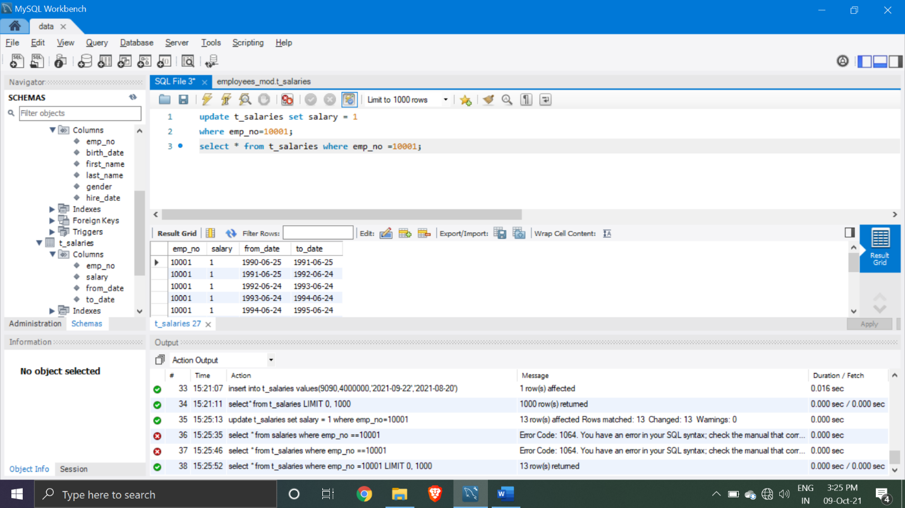

Q10> show the average salary

select avg(salary) from t_salaries;

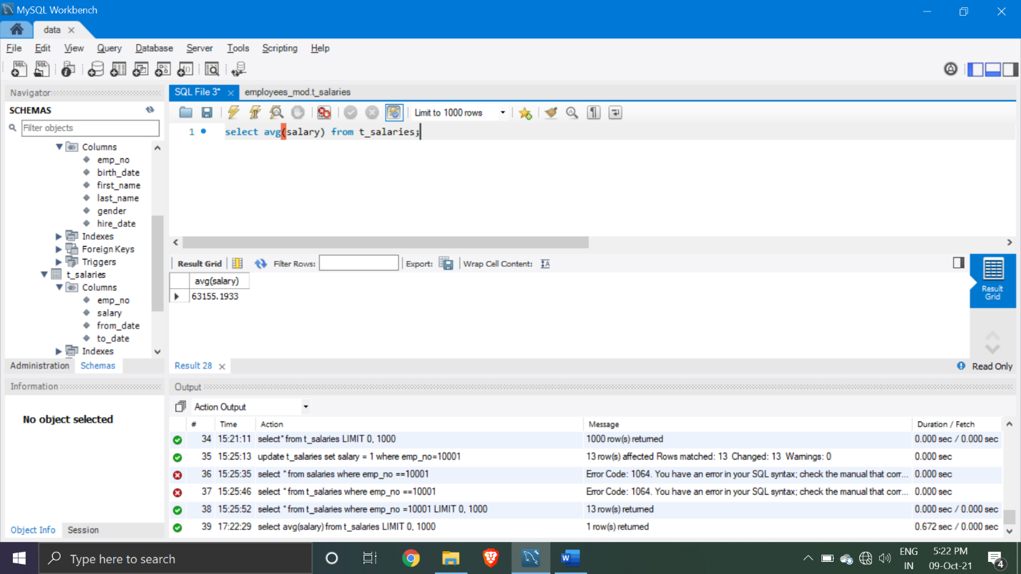

Q11.> Extract a list containing information about all managers’ employee number, first and last name, department number, and hire date.

use employees;

SELECT

e.emp_no,

e.first_name,

e.last_name,

dm.dept_no,

e.hire_date

FROM

employees e

JOIN

dept_manager dm ON e.emp_no = dm.emp_no;

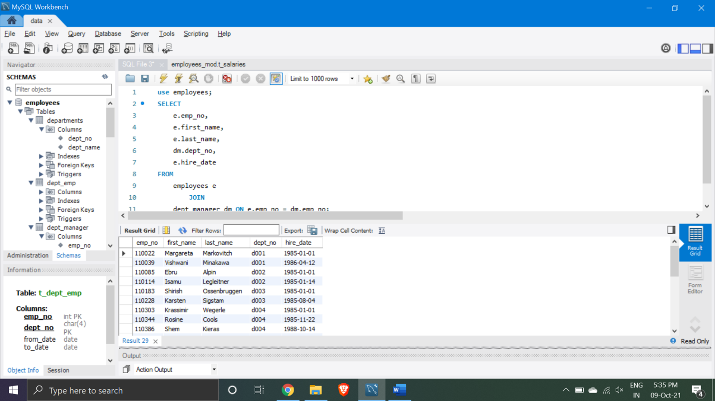

Q12> Join the 'employees' and the 'dept_manager' tables to return a subset of all the employees whose last name is Markovitch. See if the output contains a manager with that name.

SELECT

e.emp_no,

e.first_name,

e.last_name,

dm.dept_no,

dm.from_date

FROM

employees e

right JOIN

dept_manager dm ON e.emp_no = dm.emp_no

WHERE

e.last_name = 'Markovitch'

ORDER BY dm.dept_no DESC, e.emp_no;

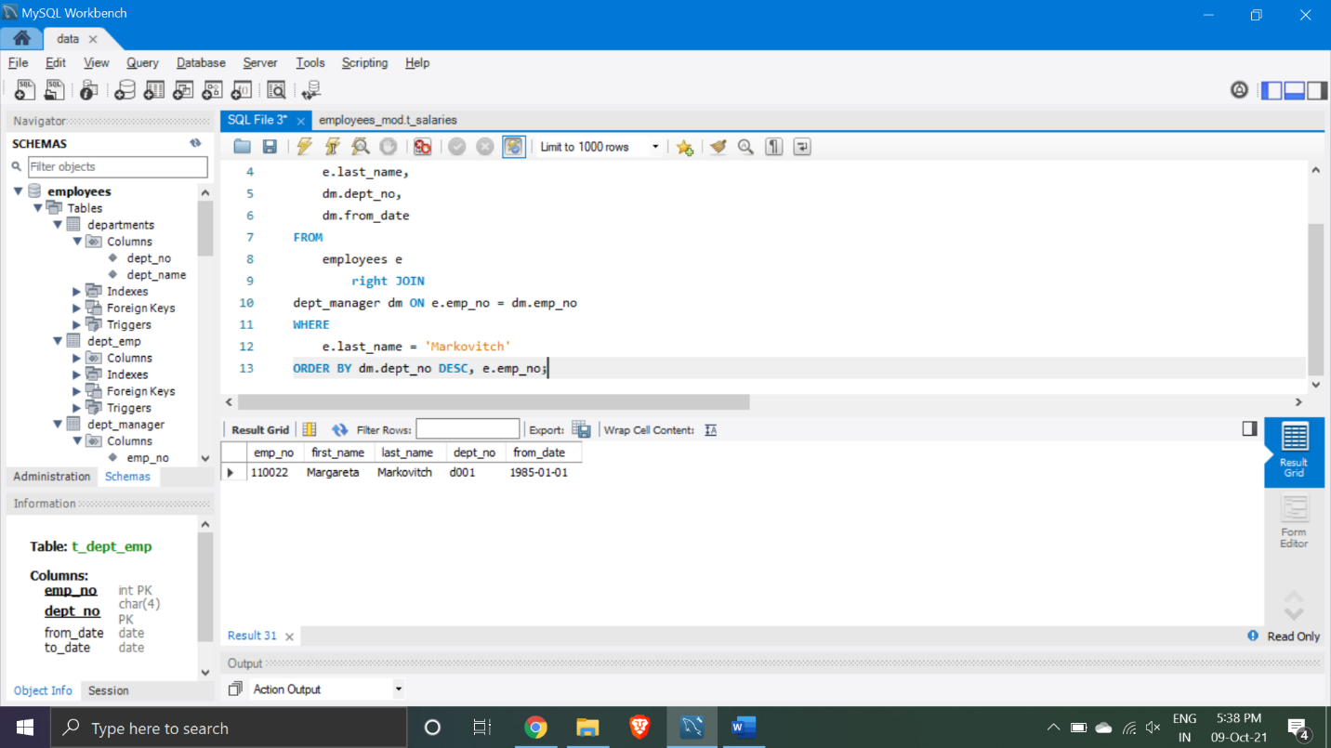

Q13> Extract the information about all department managers who were hired between the 1st of January 1990 and the 1st of January 1995.

SELECT *

FROM

dept_manager

WHERE

emp_no IN (SELECT

emp_no

FROM

employees

WHERE

hire_date BETWEEN '1990-01-01' AND '1995-01-01');

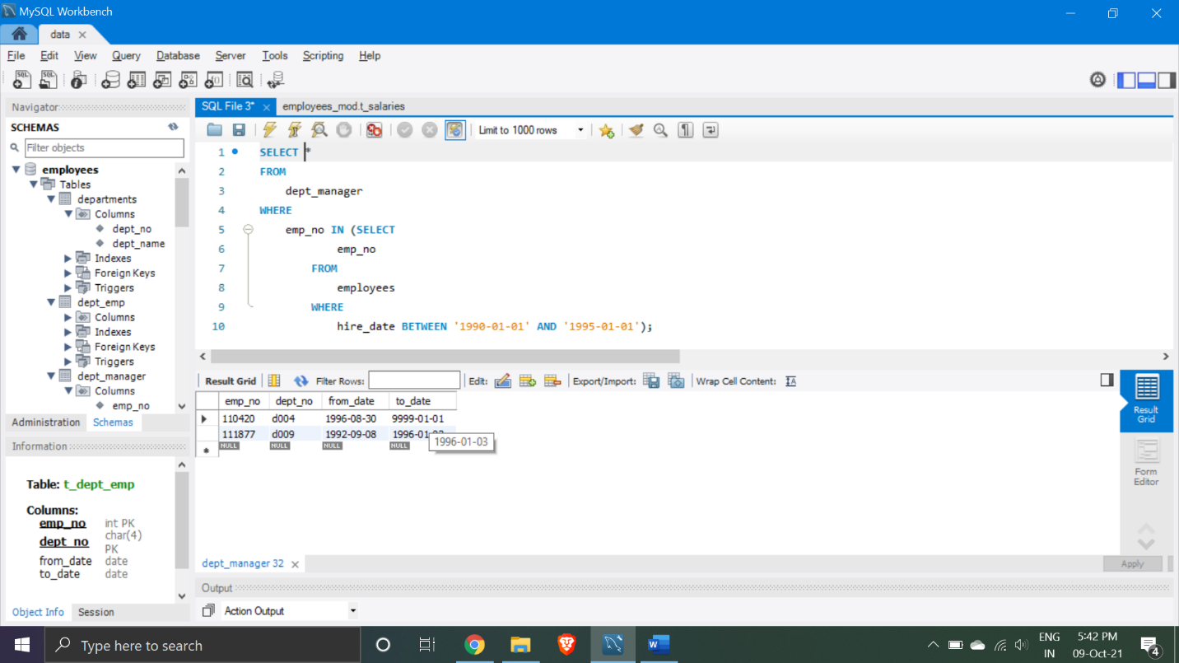

Q14> Starting your code with “DROP TABLE”, create a table called “emp_manager” (emp_no – integer of 11, not null; dept_no – CHAR of 4, null; manager_no – integer of 11, not null).

**DROP TABLE IF EXISTS emp_manager;**

**CREATE TABLE emp_manager (**

**emp_no INT(11) NOT NULL,**

**dept_no CHAR(4) NULL,**

**manager_no INT(11) NOT NULL**

**);**



Q15>select the department start with C

select * from departments where dept_name like 'C%';

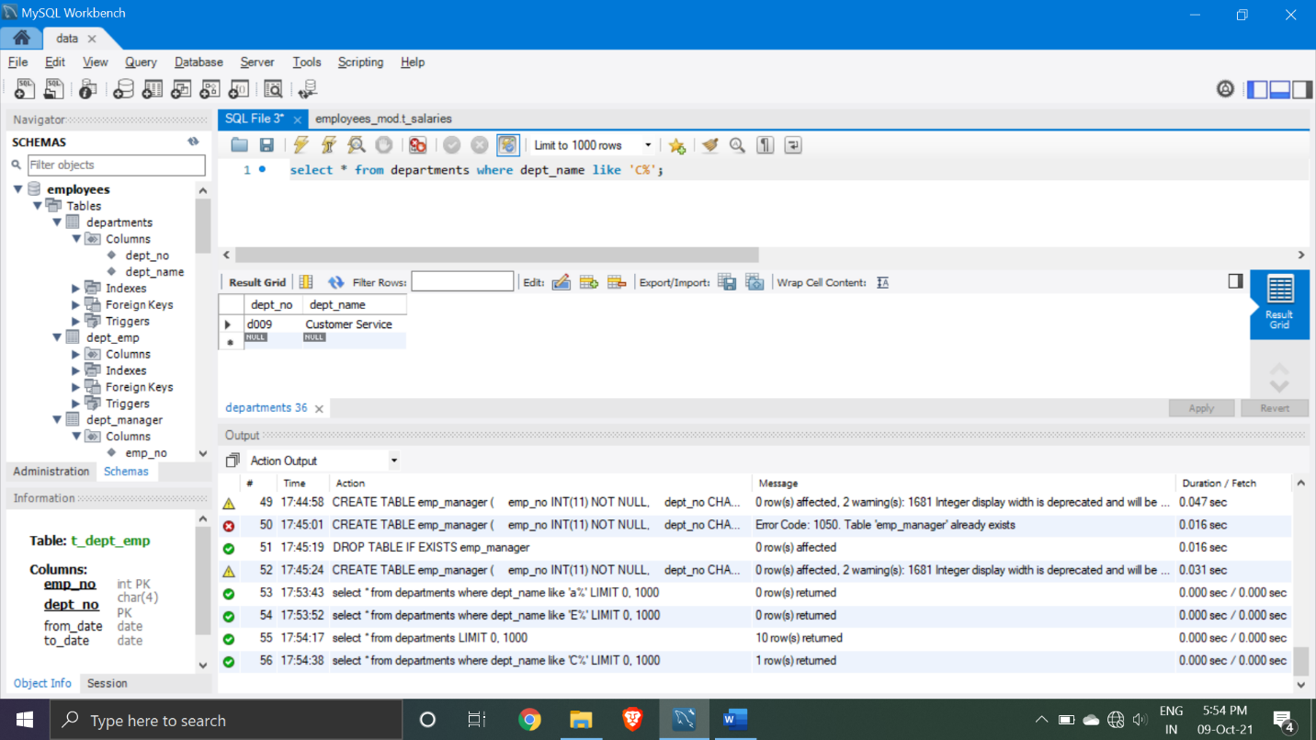

Q16> find sum of salaries

use employees_mod;

select sum(salary) from t_salaries;

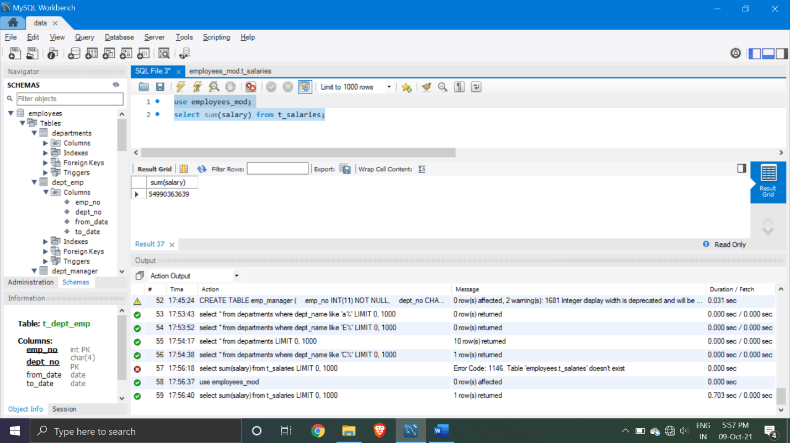

Q17> show name of employees having salary greate than average salary

select first_name,salary from t_employees

inner join t_salaries

on t_employees.emp_no=t_salaries.emp_no where salary >(select avg(salary) from t_salaries);

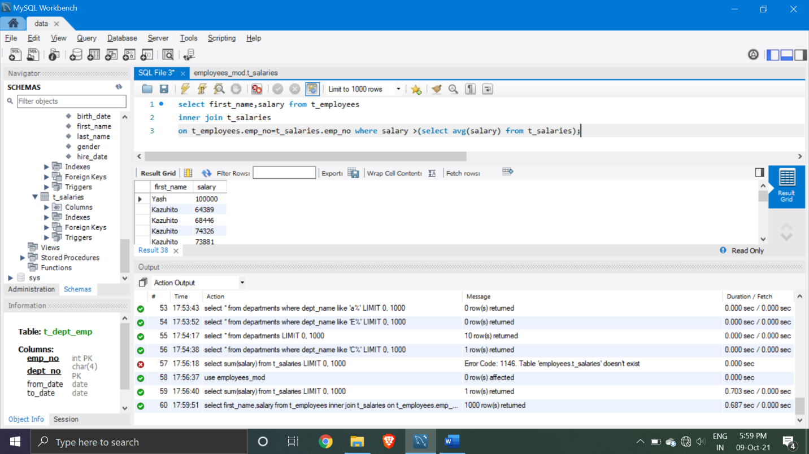

Q18>count the gender from employees

select count(gender) from t_employees;

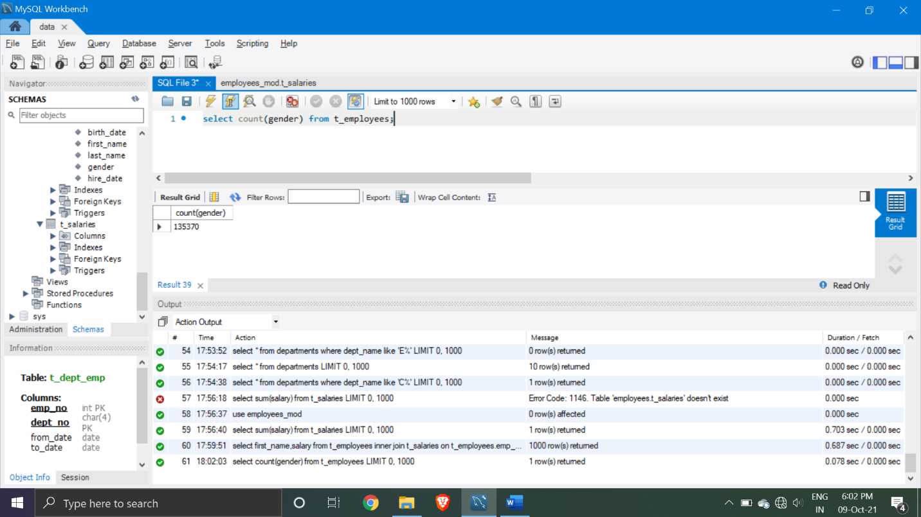

Q19> show the name and birth date of employees where gender is equal to female

select first_name,last_name,birth_date from t_employees where gender='F';

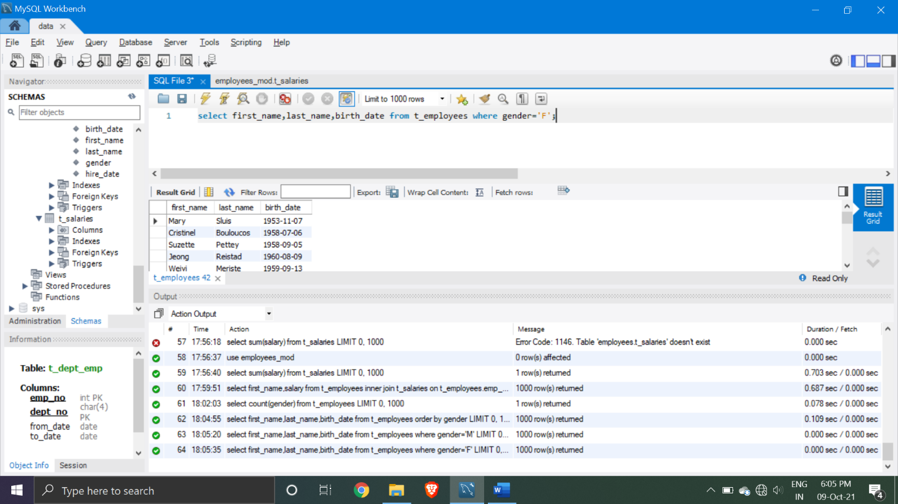

Q20>select maximum department number

select max(dept_no) from t_dept_manager;

